**Lab report no 4**



**Fall 2022**

# Control System Lab

**Submitted By**

**Name Registration No**

# Muhammad Ali 19pwcse1801

Section: **A**

**Date**: 09,11,22

**Submitted to: Dr Muniba Ashfaq**

Department of Computer Systems Engineering

University of Engineering and Technology, Peshawar

**Objectives: -**

* To understand different combination of LTI system.
* To learn how to find output of series and parallel of system.
* And to compare both resultant of MATLAB and Simulink.

**Task no 1: -( Series combination)**

**Code: -**

clc

clear all

close all

%g1

num1 = [1];

denum1 =[1 1];

%g(2)

num2 = [1];

denum2 =[1 3];

%g(3)

num3 = [1 3];

denum3 =[1 5];

sys1 = tf( num1,denum1); %three system g1,g2,g3

sys2 = tf( num2,denum2);

sys3 = tf( num3,denum3);

%series

%first two system in series

series1 = series(sys1,sys2);

%third system in series with two

eq1 = series(series1,sys3);

step(eq1);

**Plot: -**

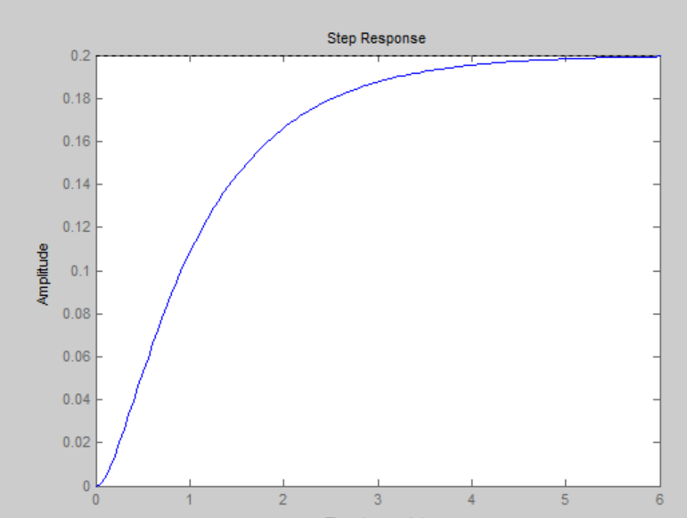

**Simulink: -**

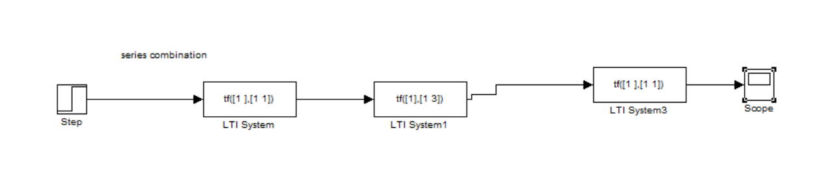

**Scope: -**

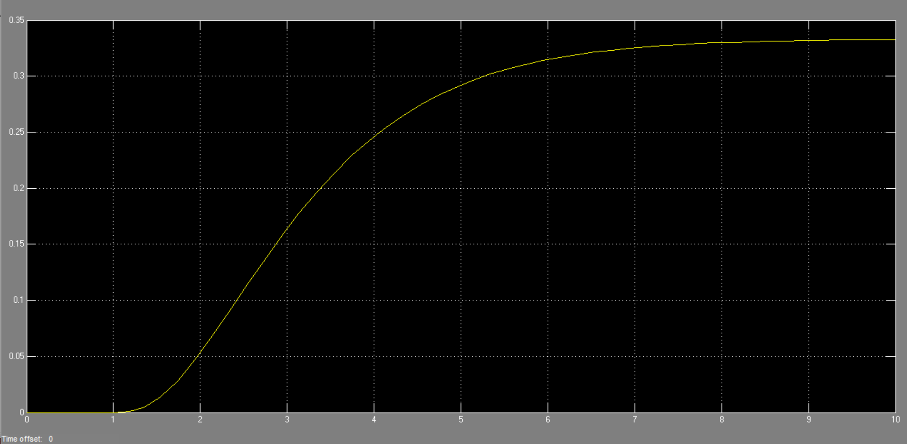

**Task no 2: - (parallel)**

**Code: -**

clc

clear all

close all

%g1

num1 = [1];

denum1 =[1 1];

%g(2)

num2 = [1];

denum2 =[1 3];

%g(3)

num3 = [1 3];

denum3 =[1 5];

sys1 = tf( num1,denum1); %three system g1,g2,g3

sys2 = tf( num2,denum2);

sys3 = tf( num3,denum3);

%parallel

%first two system in series

paralle1 = parallel(sys1,sys2);

%third system in series with two

eq = parallel(paralle1,sys3);

step(eq);

**Plot: -**

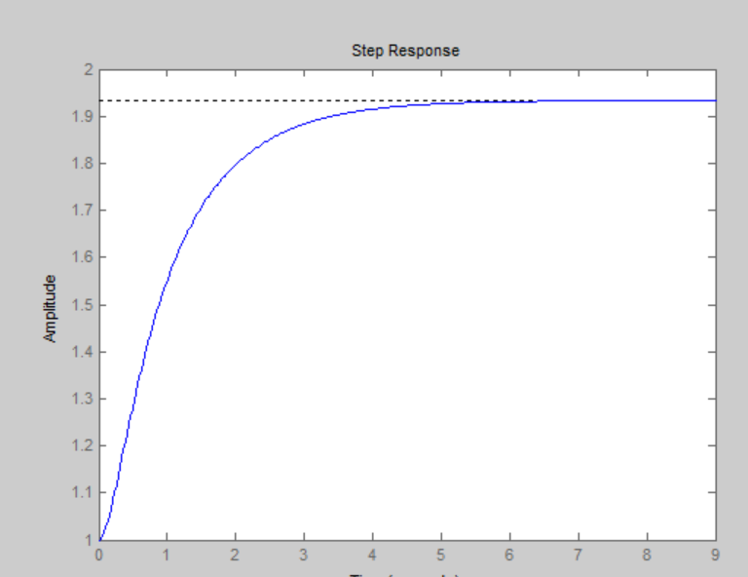

**Simulink: -**

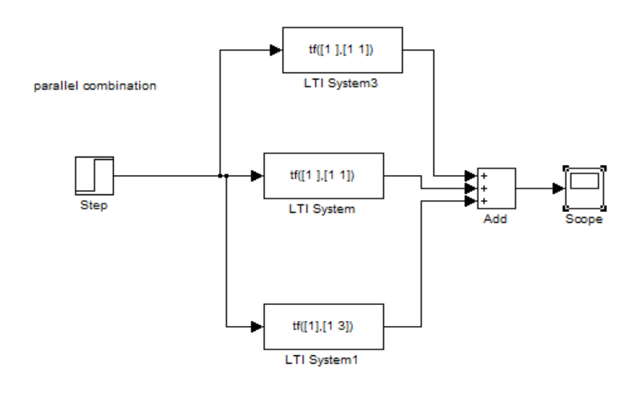

**Scope: -**

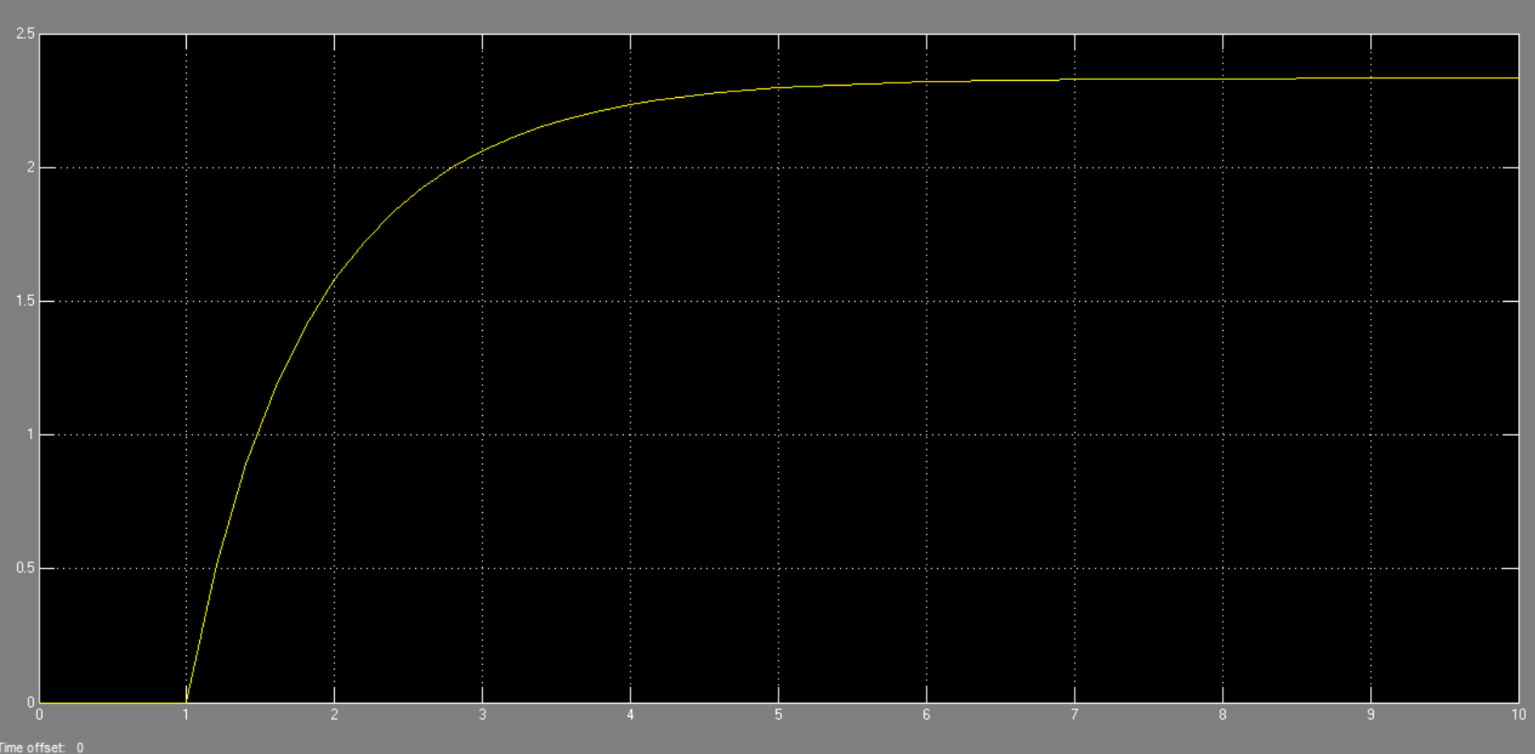

**Task no 3: -**

**Code: -**

clc

clear all

close all

%g1

num1 = [1];

denum1 =[1 1];

%g(2)

num2 = [1];

denum2 =[1 3];

%g(3)

num3 = [1 3];

denum3 =[1 5];

sys1 = tf( num1,denum1);

sys2 = tf( num2,denum2);

sys3 = tf( num3,denum3);

series1 = series(sys1,sys2);

parellel1 = parallel(sys3,sys1);

series2 = series(series1,parellel1);

series_eq = series(sys2,sys3);

feedbk = feedback(series_eq,sys3);

eq = parallel(series2,feedbk);

step(eq);

**Plot: -**

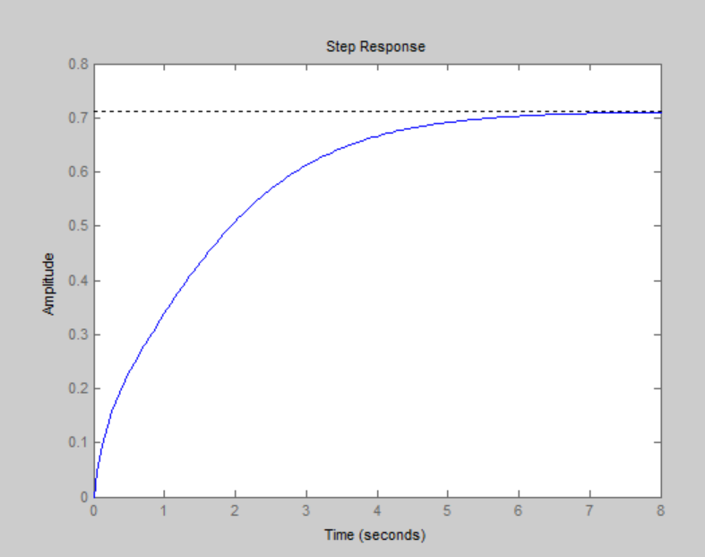

**Simulink: -**

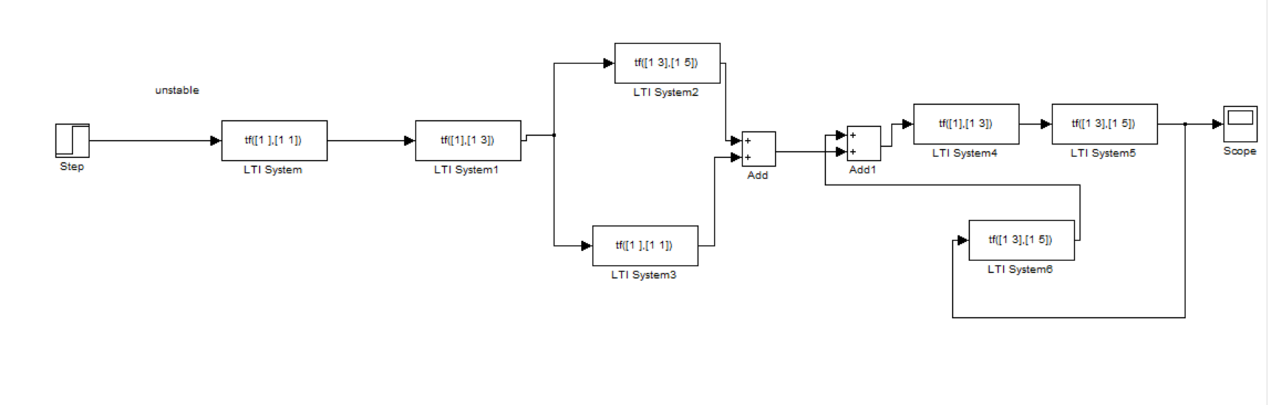

**Scope: -**

